What is Kubernetes?

* K8s is open source orchestration platform
* K8s used to managed containers
* K8s developed in GOOGLE & donated to CNCF (Cloud Native Computing Foundation)
* Kubernetes provides a framework for managing the complex tasks of deploying, scaling, and operating applications in containers

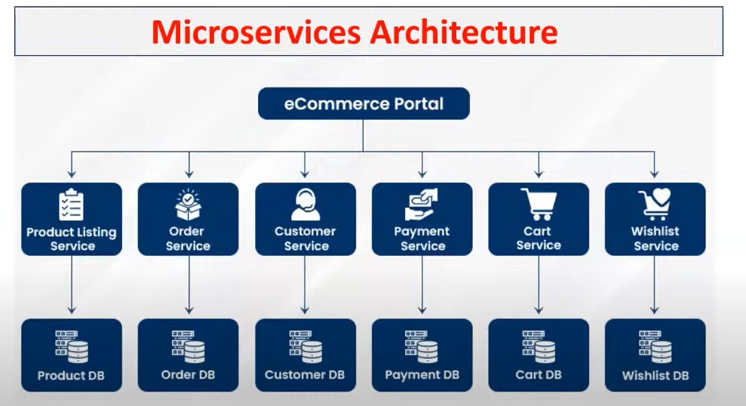

Kubernetes Advantages

* Container Orchestration
* Scalability
* Self-Healing
* Load Balancing

K8s Architecture

* K8s works based on cluster architecture
* Clusters means group of servers

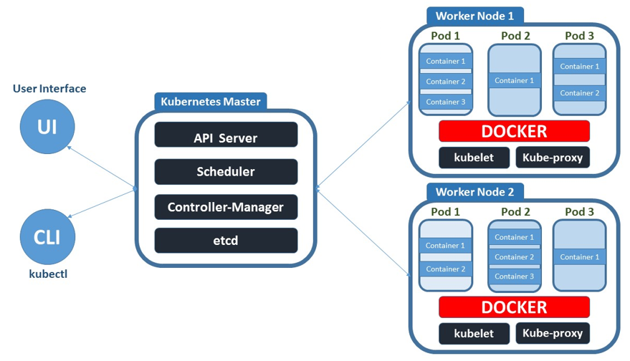

1. Control plane / Master Node
2. Worker Nodes
3. Kubectl

K8s control plane will contain below components

* API Server
* Scheduler
* Control Manager
* ETCD

K8S worker node will container below components

Pod

Containers

Docker Engine

Kublet

Kube Proxy

To communicate with K8S control plane we have 2 options

UI (Web Dashboard)

Kubectl (CLI)

K8S Architecture Components

* API Server will receive incoming requests and it will store into ETCD
* ETCD is k8s cluster database
* Scheduler will check pending tasks in ETCD and it will schedule those task in worker node
* Scheduler will get available workers nodes information by using kubelet .
* Kubelet is called as worker node agent
* Kube-proxy provides network for cluster communication

In K8s our project will be executed as a POD . Inside POD containers available

Controller-Manager will monitor all k8s resources functionality

Kubernetes Cluster Setup

Kubernets Cluster we can setup in multiple ways

**Self Managed K8S Cluster**

* Mini Kube (single Node Cluster)
* Kubeadm (Multi Node Cluster)

**Managed K8S Cluster**

* AWS EKS
* Azure AKS
* GCP GKE
* IBM IKE